

|  |
| --- |
| **Course: Embedded Electronic Devices and Programming** |
| Laboratory work № 3 |
| “Handling Interrupt Request” |

|  |  |
| --- | --- |
| Student name and surname: | Nikita Goloviznins |
| Student code: | St78436 |
| Group: | 4103BDA |
| Lecturer: | Artjoms Ivanovs |

|  |  |
| --- | --- |
| Date performed: | 12.05.2023 |

Riga

2023

TABLE OF CONTENTS

Ⅰ Task 2

Ⅱ Individual variant 3

Ⅲ Microcontroller I/O diagram 4

Ⅳ Algorithm 5

Ⅴ Program code 6

Ⅵ Conclusion 7

Ⅰ Task

* to develop of the microcontroller I/O diagram;
* to create an algorithm of main function and an algorithm(-s) of handling interrupt requests for the ATMega48 microcontroller in accordance with an individual task;
* to create program code in Atmel Studio 7 environment;
* to debug the program in Atmel Studio 7 environment;
* to issue a report on laboratory work.
* to form time intervals, use functions that form delays;
* when debugging a program in the Atmel Studio 7 environment, the call of functions that generate delays must be commented out;
* the clock frequency of the ATMega48 microcontroller is 8 MHz;
* when the button is pressed on the input/output line of the port - logical "0", when the button is released on the input/output line of the port - logical "1";
* the LED is turned on by logical "0" on the I/O line of the port, and turned off by logical "1";

Ⅱ Individual variant

*Variant № 15.* Timer T0 operates in the external event counter mode. Event - pressing the SW0 button connected to the PD4 line. Using the T1 timer and LEDs, provide an indication in binary code of the number of times SW0 has been pressed in the last 5 s.

Ⅲ Microcontroller I/O diagram

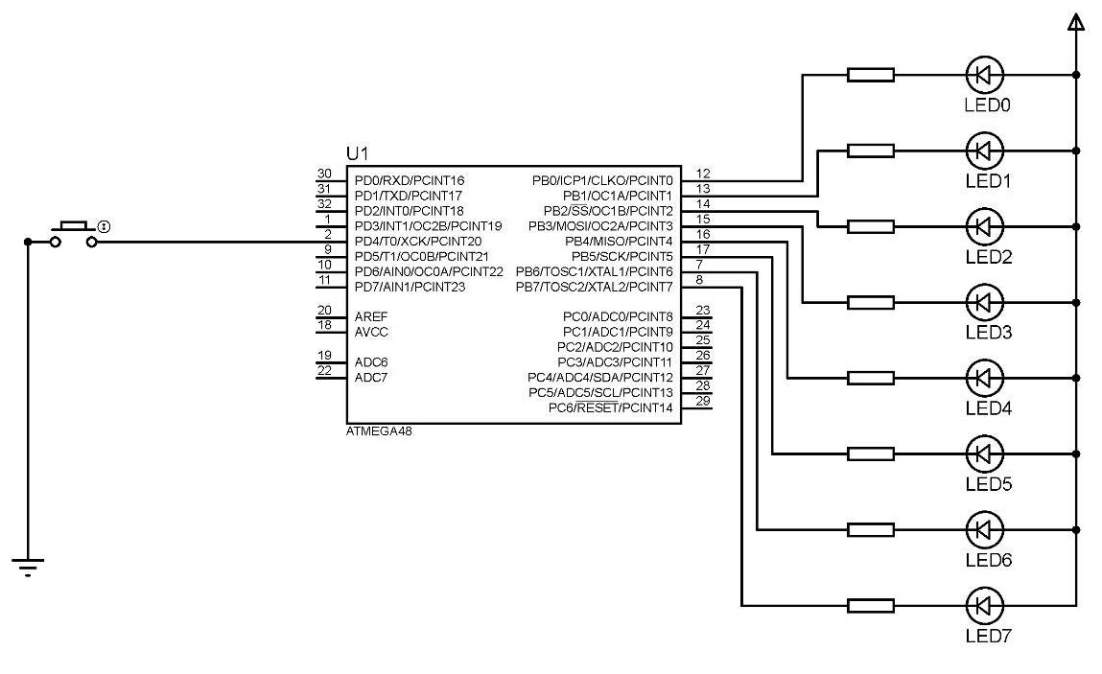

**Figure 1. ATMEGA48 I/O diagram**

Ⅳ Algorithm

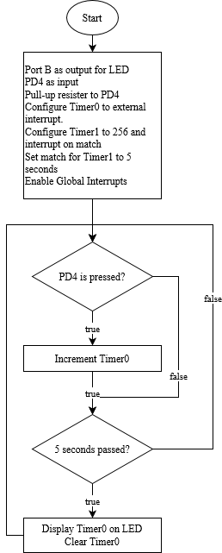

**Figure 2. ATMEGA48 algorithm**

Ⅴ Program code

#include <avr/io.h>

#include <avr/interrupt.h>

#define BUTTON PD4

ISR(TIMER1_COMPA_vect){

PORTB = ~TCNT0;

TCNT0 = 0;

}

int main(void)

{

DDRB = 0xFF;

PORTB = 0xFF;

DDRD &= ~(1 << BUTTON); // Set button pin as input

PORTD = 1 << 4; // Connecting a pull-up resistor to PD4 pin

TCCR1B = (1<<CS12) | (1<<CS10) | (1<<WGM12); //clk/1024

TIMSK1 = (1<<OCIE1A); //Enable Output compare A match interrupt

TCCR0B = (1<<CS02) | (1<<CS01); //Config Timer T0 to External clock source

OCR1A = 39062; //Set the Top value for Timer/Counter1 5 sec

sei(); //Enable global interrupts

while (1)

{

}

}

Ⅵ Conclusion

In this laboratory work, the task was to develop a program for the ATMEGA48 microcontroller to show on LEDs the number of times the button SW4 was pressed during the 5 second interval.

To implement this task, the I/O diagram of the microcontroller was created, and the main function algorithm was developed. The program code was written in Atmel Studio 7 (currently known as Microchip Studio) environment and tested by debugging. Time intervals were formed using internal Timer1 and Timer0 was used as a counter, configured to external clock source. The clock frequency of the ATMEGA48 microcontroller is 8 MHz.

The program code was developed and tested in accordance with the individual task requirements. The features of the program include the use of inverse LED logic, where setting the LED pin to 0 turns the LED on and setting it to 1 turns it off. The program also includes the use of a pull-up resistor on the button pin.

During testing, the program worked as expected, showing the number of times the button SW4 was pressed during the 5 second interval. The report on this laboratory work was prepared, containing all the necessary information about the program and its implementation.